Wholesale Customers – Supervised Learning Business Case
1: Business Understanding
i) What is the business problem the wholesale distributor is trying to solve.?
The wholesale distributor wants to identify whether a customer belongs to Retail or HORECA (Hotels, Restaurants, Cafés) based on their historical purchasing behavior. By analyzing how much customers spend on different product categories such as Fresh, Milk, Grocery, Frozen, Detergents_Paper, and Delicassen, the company aims to build a predictive model that can classify customer types accurately. This helps the business better understand customer segments and make data-driven decisions for marketing strategies, inventory management, and delivery operations.

ii) Why is supervised learning suitable for this problem?
Supervised learning is suitable for this problem because the dataset already contains labeled data, where the Channel column indicates the customer type (HORECA or Retail). Using these labeled examples, machine learning algorithms can learn the relationship between customer purchasing patterns and their customer type. Once the model is trained, it can predict the type of new customers based on their spending behavior, helping the business make better decisions.

iii) How can predicting customer type help improve business decisions?
Predicting customer type helps the company understand the purchasing behavior of different customers such as Retail and HORECA. This information allows the business to design targeted marketing strategies, offer suitable pricing, and plan inventory more effectively based on customer demand. It also helps improve delivery planning and customer service, leading to better operational efficiency and increased profitability.

Dataset Description

The Wholesale Customers dataset contains information about the annual spending of customers from a wholesale distributor across different product categories. Each row in the dataset represents a single customer, while each column represents the annual expenditure on a particular product category.
The dataset is used to analyze customer purchasing behavior and build a supervised learning model to predict the type of customer (Retail or HORECA).

Key Features in the Dataset
1. Channel Represents the type of customer.
- HORECA (Hotels, Restaurants, Cafés)
- Retail customers
2. Region Indicates the geographical region of the customer.
- Lisbon
- Porto
- Other regions
3.Fresh - Annual spending on fresh food products such as fruits, vegetables, and meat.
4.Milk - Annual spending on milk and dairy products.
5.Grocery - Annual spending on grocery items such as packaged food and household consumables.
6. Frozen - Annual spending on frozen food products.
7.Detergents_Paper - Annual spending on cleaning products, detergents, and paper items.
8. Delicassenz - Annual spending on delicatessen items such as prepared foods and specialty products.
Summary
These features capture the purchasing patterns of customers across different product categories. By analyzing these patterns, supervised machine learning algorithms can be used to predict the customer type (Channel) and help the business make better marketing, inventory, and operational decisions.

2: Dataset Understanding

i) Load the dataset and examine its structure.
The dataset was loaded using the Pandas library in Python to analyze its structure. It contains 440 rows and 8 columns, where each row represents a customer and each column represents spending on different product categories. The Channel column is the target variable indicating customer type (HORECA or Retail), and the other columns represent annual spending patterns of customers.
ii) Identify the target variable(s) and input features
The target variable in this dataset is Channel, which represents the type of customer (HORECA or Retail). The goal of the model is to predict this variable.
The input features are Region, Fresh, Milk, Grocery, Frozen, Detergents_Paper, and Delicassen. These variables represent the annual spending of customers on different product categories and are used to predict the customer type.

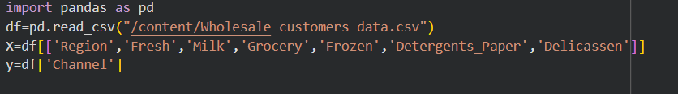

3: Data Quality & Preprocessing
i) Check for missing values and duplicates in the dataset.
The dataset was checked for missing values and duplicate records using Pandas functions. After examining the data, it was found that there are no missing values and no duplicate rows in the dataset. This indicates that the dataset is clean and ready for further analysis and model building.
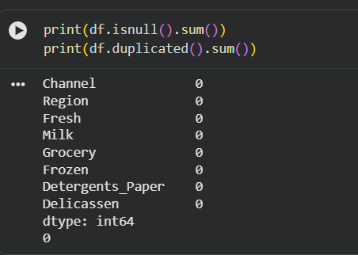

ii) Encode categorical variables such as Channel or Region.
Categorical variables such as Channel and Region need to be encoded into numerical values so that machine learning algorithms can process them. In this dataset, Channel is already encoded as 1 (HORECA) and 2 (Retail). The Region variable can be encoded using techniques such as label encoding or one-hot encoding to convert the categories into numerical form for model training.

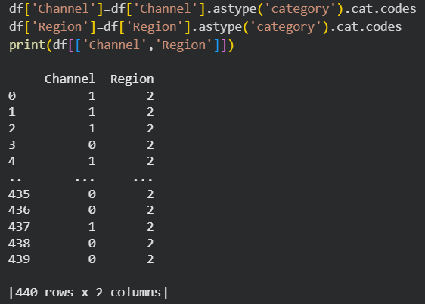

iii) Scale numerical features where required.

Numerical features such as Fresh, Milk, Grocery, Frozen, Detergents_Paper, and Delicassen contain spending values that vary widely in scale. Some customers may spend very large amounts in one category while much less in another. Because of these differences, feature scaling is applied to normalize the data. Techniques such as Standardization (StandardScaler) or Min-Max Scaling are commonly used for this purpose

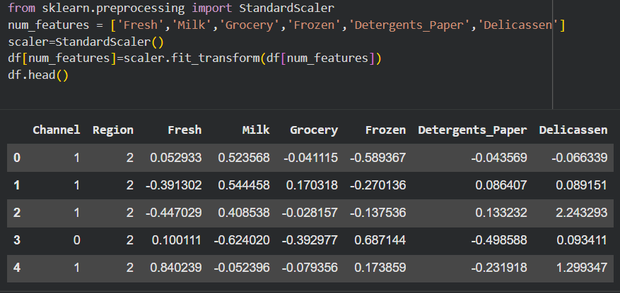

iv) Explain why preprocessing is important for supervised learning models.
Data preprocessing is an important step in supervised learning because it prepares the raw data for model training. It involves tasks such as handling missing values, encoding categorical variables, and scaling numerical features. Proper preprocessing helps improve the quality and consistency of the dataset. It also ensures that machine learning algorithms can process the data efficiently. As a result, preprocessing helps improve the accuracy, reliability, and overall performance of supervised learning models.

4: Exploratory Data Analysis (EDA)
i) Compare spending patterns across different customer types.

Spending patterns differ between HORECA and Retail customers. HORECA customers generally spend more on Fresh and Frozen products, as these items are commonly used in hotels, restaurants, and cafés. In contrast, Retail customers tend to spend more on Grocery, Milk, and Detergents_Paper products. These differences in purchasing behavior help distinguish between the two customer types and are useful for building classification models.

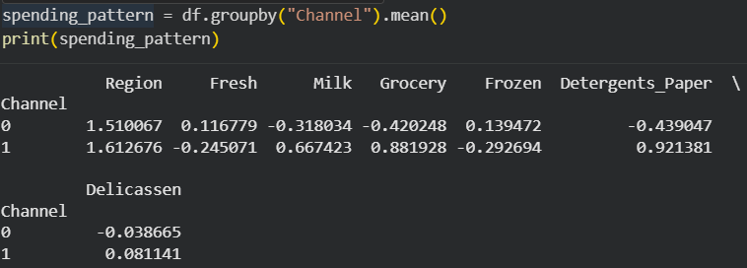
ii) Identify which product categories best differentiate Retail and HORECA customersProduct categories such as Grocery, Milk, and Detergents_Paper strongly differentiate Retail customers from HORECA customers, as Retail customers generally spend more on these items. On the other hand, Fresh and Frozen products are typically purchased more by HORECA customers because they are commonly used in hotels, restaurants, and cafés. These differences in spending patterns help clearly distinguish between the two customer types.

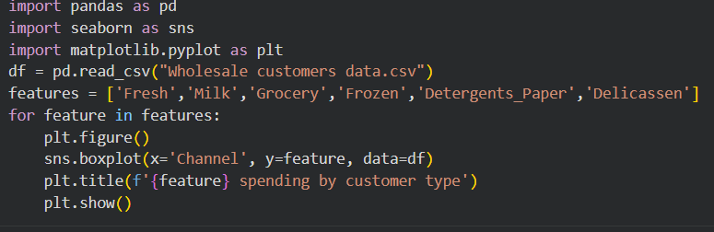

iii) Summarize key insights from EDA that can influence model selection.

Exploratory Data Analysis (EDA) shows that different customer types have distinct spending patterns across product categories. Retail customers generally spend more on Grocery, Milk, and Detergents_Paper, while HORECA customers spend more on Fresh and Frozen products. These differences indicate that the features are useful for classification. Therefore, supervised learning models such as Logistic Regression, Decision Tree, or Random Forest can effectively learn these patterns to predict the customer type.

5: Feature Selection

i) Select relevant features for model training.
The relevant features selected for model training include Region, Fresh, Milk, Grocery, Frozen, Detergents_Paper, and Delicassen. These variables represent the annual spending behavior of customers across different product categories. The Channel variable is used as the target variable, while the remaining features act as input variables to train the model and predict the type of customer.

ii)Justify the inclusion or exclusion of specific features.

Features such as Fresh, Milk, Grocery, Frozen, Detergents_Paper, and Delicassen are included because they represent the purchasing behavior of customers, which helps in distinguishing between Retail and HORECA customers. The Region feature may also be included as it provides additional information about customer location. The Channel variable is excluded from input features because it is the target variable that the model aims to predict.

iii) Explain how feature selection impacts model performance.

Feature selection plays an important role in improving the performance of machine learning models. By selecting only the most relevant features, the model can focus on the important patterns in the data. This helps reduce noise and unnecessary complexity in the dataset. Proper feature selection can also improve model accuracy, reduce overfitting, and make the model faster and more efficient.
6: Model Selection

i) Choose at least two supervised learning

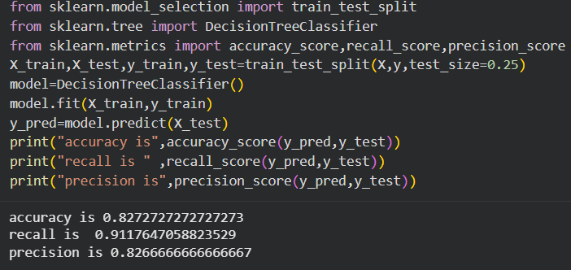
Decision Tree :- A Decision Tree is a classification algorithm that splits the dataset into branches based on feature values to predict the target variable. It is easy to understand and helps identify important features influencing the prediction.

Random Forest :- A Random Forest is an ensemble learning algorithm that builds multiple decision trees and combines their predictions to improve accuracy. It reduces overfitting and generally provides better performance compared to a single decision tree model.

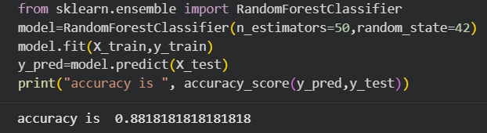

ii) Explain the working principle of each selected algorithm.

The Decision Tree algorithm works by splitting the dataset into smaller groups based on feature values. It selects the best feature at each step using measures such as Gini Index or Entropy to create decision rules. The data is repeatedly divided into branches until the model can classify the target variable.

The Random Forest algorithm works by creating multiple decision trees using different random samples of the dataset. Each tree makes its own prediction, and the final result is determined by majority voting among all the trees. This method improves accuracy and reduces overfitting.

iii) Discuss why these models are suitable for the given business problem.

Decision Tree and Random Forest models are suitable for this problem because they can easily handle classification tasks and identify patterns in customer purchasing behavior. These models work well with numerical features such as spending on different product categories. A Decision Tree helps in understanding how different features influence customer classification, while Random Forest improves prediction accuracy by combining multiple decision trees. Therefore, these models are effective for predicting whether a customer is Retail or HORECA based on their spending patterns.

7: Model Training & Validation

i) Split the dataset into training and testing sets.

The dataset is divided into training and testing sets to evaluate the performance of the machine learning model. The training set is used to train the model and learn patterns from the data, while the testing set is used to evaluate how well the model performs on unseen data. Commonly, the dataset is split using an 80:20 ratio, where 80% of the data is used for training and 20% for testing.

ii) Train the selected models on the training data.

The selected models, Decision Tree and Random Forest, are trained using the training dataset. During training, the models learn the relationship between the input features and the target variable (Channel). The algorithms analyze the patterns in customer spending behavior to build a model that can classify customers as Retail or HORECA. Once training is completed, the models are ready to make predictions on the test data.

iii) Validate model performance using appropriate metrics.

The performance of the trained models is validated using evaluation metrics such as Accuracy, Precision, Recall, and F1-score. These metrics help measure how well the model correctly classifies customers into Retail or HORECA categories. A Confusion Matrix can also be used to visualize the number of correct and incorrect predictions made by the model.

8: Model Evaluation

i) Evaluate models using metrics such as Accuracy, Precision, Recall, F1-score, and Confusion Matrix

The performance of the models is evaluated using classification metrics. Accuracy measures the overall percentage of correct predictions made by the model. Precision shows how many predicted positive cases are actually correct, while Recall measures how well the model identifies actual positive cases. The F1-score balances precision and recall. A Confusion Matrix is used to visualize correct and incorrect predictions made by the model.

Logistic Regression :- Logistic Regression is a supervised machine learning algorithm used for classification problems. It predicts the probability of a categorical outcome using input features. In this project, Logistic Regression can be used to classify customers as Retail or HORECA based on their spending patterns. The model uses a logistic (sigmoid) function to convert predicted values into probabilities between 0 and 1, which helps in making classification decisions.

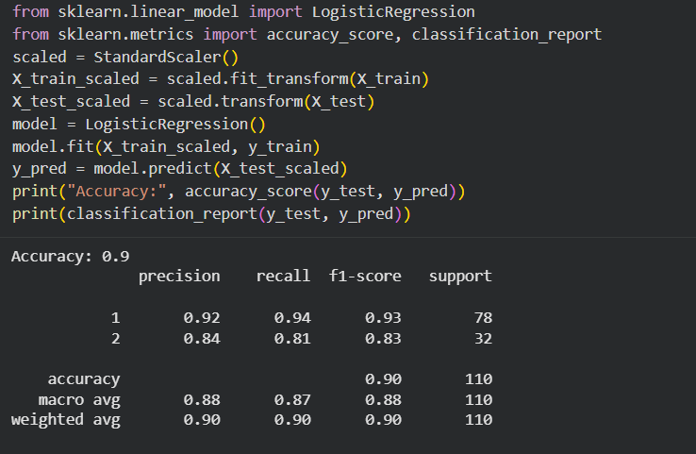

ii) Compare the performance of different models.

The performance of different models such as Logistic Regression, Decision Tree, and Random Forest is compared using evaluation metrics like Accuracy, Precision, Recall, and F1-score. By comparing these metrics, we can determine which model performs better in predicting customer type. The model with higher accuracy and better overall evaluation scores is selected as the final model.

iii) Select the final model and justify your choice.

Based on the evaluation results, the Random Forest model is selected as the final model because it provides higher accuracy and better overall performance compared to other models. Random Forest reduces overfitting by combining multiple decision trees and making predictions through majority voting. This makes the model more reliable and effective for predicting whether a customer belongs to Retail or HORECA.

9: Model Interpretation

i) Interpret model results and identify important features influencing predictions.

The model results show that certain features have a strong influence on predicting the customer type. Features such as Grocery, Milk, and Detergents_Paper play an important role in identifying Retail customers, while Fresh and Frozen are more associated with HORECA customers. These spending patterns help the model distinguish between different customer types and improve prediction accuracy.
ii) Explain how purchasing behavior affects customer classification.

Customer classification is influenced by their purchasing behavior across different product categories. Customers who spend more on Fresh and Frozen products are often classified as HORECA, as these items are commonly used in hotels, restaurants, and cafés. In contrast, customers who spend more on Grocery, Milk, and Detergents_Paper are usually classified as Retail customers. These differences in spending patterns help the machine learning model accurately classify the customer type.

10: Business Insights & Recommendations

i) What insights can be derived about different customer types?

The analysis shows that different customer types have distinct purchasing patterns. HORECA customers tend to spend more on Fresh and Frozen products, which are commonly used in hotels, restaurants, and cafés. In contrast, Retail customers generally spend more on Grocery, Milk, and Detergents_Paper products. These insights help the company understand customer needs and segment customers more effectively.

ii) How can the company use these predictions for targeted marketing and inventory optimization?

The company can use these predictions to create targeted marketing strategies for different customer types. For example, promotions for fresh and frozen products can be targeted to HORECA customers, while grocery and household products can be promoted to retail customers. These predictions also help the company plan inventory more efficiently, ensuring that the right products are stocked according to customer demand.

iii) Provide actionable recommendations for business teams.

The company should use customer classification to segment customers and design targeted marketing campaigns for different groups. The business team can also improve inventory planning by stocking products based on the purchasing patterns of Retail and HORECA customers. Additionally, the company can offer special promotions and personalized services to increase customer satisfaction and improve sales.

11 Limitations & Future Scope

i) Discuss limitations of the current supervised learning approach.

The current supervised learning approach has some limitations. The dataset contains limited features, which may not fully represent customer behavior. The model also depends on historical data, so it may not capture future changes in purchasing patterns. Additionally, the dataset size is relatively small, which may affect the model’s generalization and prediction accuracy.

ii) Suggest additional data that could improve prediction accuracy.

Prediction accuracy can be improved by including additional data such as customer demographics, purchase frequency, order size, and transaction history. Information about seasonal demand, delivery location, and customer preferences could also help the model better understand purchasing behavior. Including more relevant data can help the model make more accurate and reliable predictions.

iii) Propose future improvements or extensions to this project.

Future improvements can include using larger datasets and additional customer information to improve prediction accuracy. More advanced machine learning models such as XGBoost or Gradient Boosting can also be tested to achieve better performance. In addition, the project can be extended by developing a real-time prediction system or dashboard to help the business team make faster and more effective decisions.

